No Zoom at the Inn?

When the Coronavirus lockdown hit, back in the spring, with public venues closing and gatherings of any size forbidden, it became obvious that we wouldn’t be able to stage live performances of the Dundee Nativity this year, either indoors or outdoors. Yet when we’re driven to our knees, that’s so often a good position for being receptive to what God is saying to us. As we prayed it over, He gave us a vision – to make the Dundee Nativity 2020 as a movie. We weren’t at all clear about how we were going to go about this, or if the Covid-19 restrictions would make it possible, but we went forward in faith.

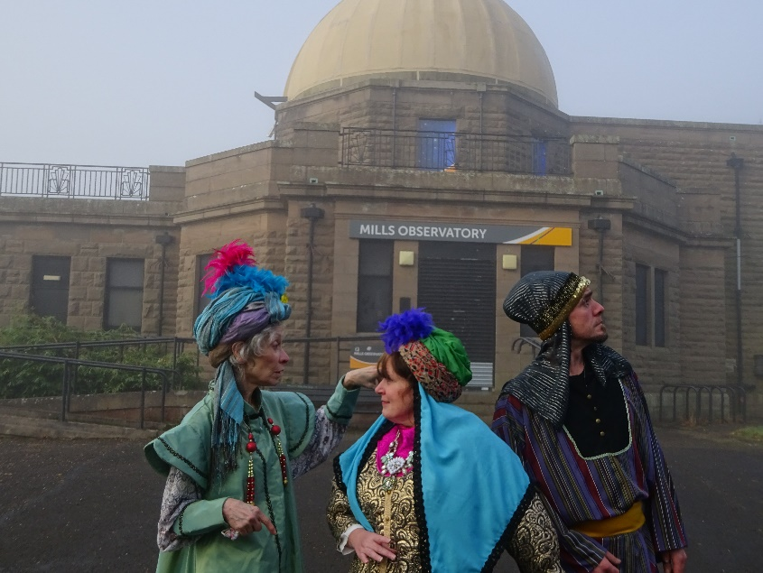

One thing we couldn’t do was tell the age-old story of the birth of Jesus as though things were normal this year. As if the pandemic wasn’t happening, and as if people weren’t experiencing real hardship and grief because of it. Our publicity each year features some well-known Dundee landmark, to make the point that the Nativity isn’t just a nice story about long ago in a faraway place, but is relevant to people in and around Dundee now. We had to acknowledge the suffering, and to relate that to why Jesus was born for us. And so, The Dundee Nativity – Celebrating a Covid Christmas began to take shape.

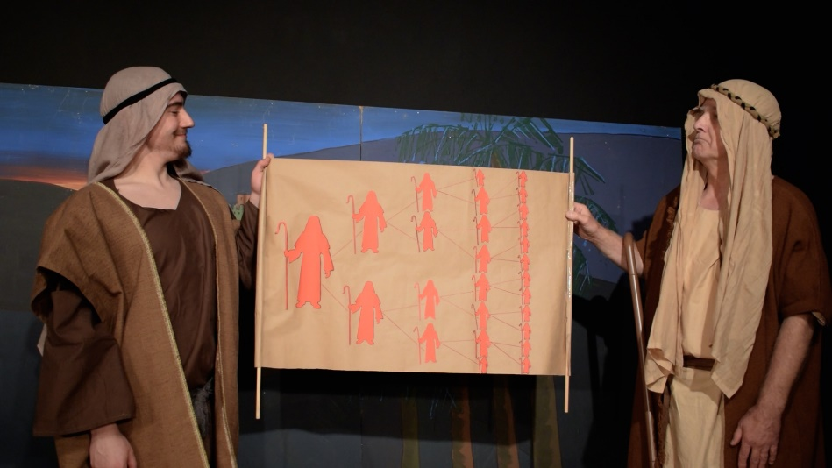

We couldn’t have everybody in the cast meeting together for our usual weekly acting and music rehearsals. Therefore, like so many other gatherings this year, we had our rehearsals on Zoom. It wasn’t ideal, what with being unable to walk about a stage as you practised your lines, or someone’s internet connection going down. We needed a stable connection: yet how could we connect with the stable in Bethlehem if there was no Zoom at the inn?

After the rehearsals, our filming sessions took place, under socially-distanced conditions, at Platform Arts. With hand sanitiser at the door, track and trace lists, and everyone being zapped with a head thermometer on arrival, we wore masks except when we were actually before the cameras, or grabbing a coffee in the two-metres-apart tables in the lounge. Even following the UK allowances for film and television production, we were limited in how many people could be in the building at one time. It all took complex timetabling and skilful editing – including the use of green screen technology – to create the illusion of numbers.

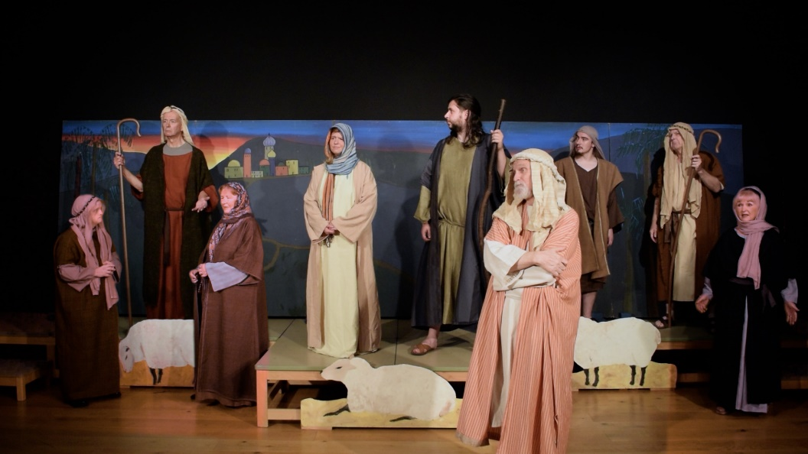

Meanwhile, the singing was recorded in a safe Dundee recording studio and lip synced in front of the camera to comply with the “no singing in public” restrictions. Another problem was that Platform Arts, as the play on the name suggests, is located next to Dundee Railway Station. While the angel train is important, we had to interrupt filming whenever an earthly locomotive pulled in or out of the station.

It was a scramble to get the editing done, the DVD copies ordered and distributed, and the completed movie put online. All this involved long hours and loss of sleep for those involved. While the main method of watching the Dundee Nativity was to be online, it was important for us to make it available for people with no access to the internet. Bulk copies of the DVD were requested by the hospitals in Tayside and Perth and Kinross, so that all patients being discharged or transferred would be offered a copy, and additional copies would go to the hospital wards. Care homes and churches also requested copies. Our Three Wise Persons from the East journeyed to Ninewells Hospital to deliver the prototype DVDs. Having this event reported by STV News helped our publicity enormously. A version of the play with audio description for visually-impaired people has also been produced, and will enable them to enjoy the play in the company of others.

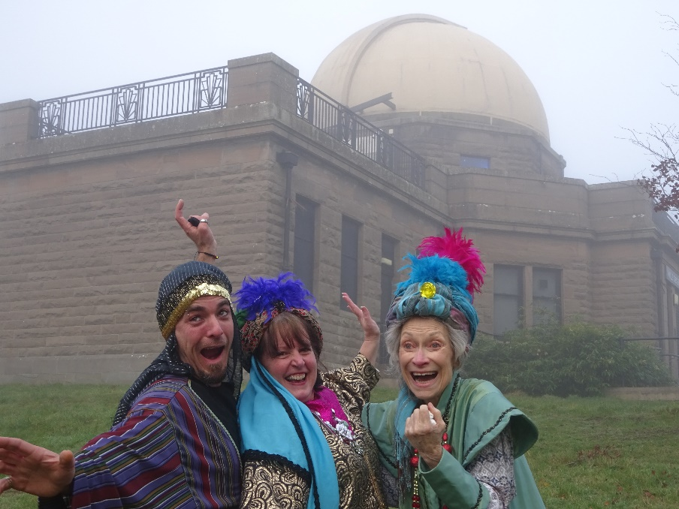

Well, the completed play arrived, despite Coronavirus, and we give thanks to God for opening a way for us when there seemed no way. We give glory to Him for His guidance throughout the whole process of making The Dundee Nativity 2020, and we offer it to Him. As Caspar says, when he and his companions are discussing the gifts they will present to Jesus:
“What we are really giving is ourselves. The gift is a symbol of that… of who we are. We give who we are to the King.”

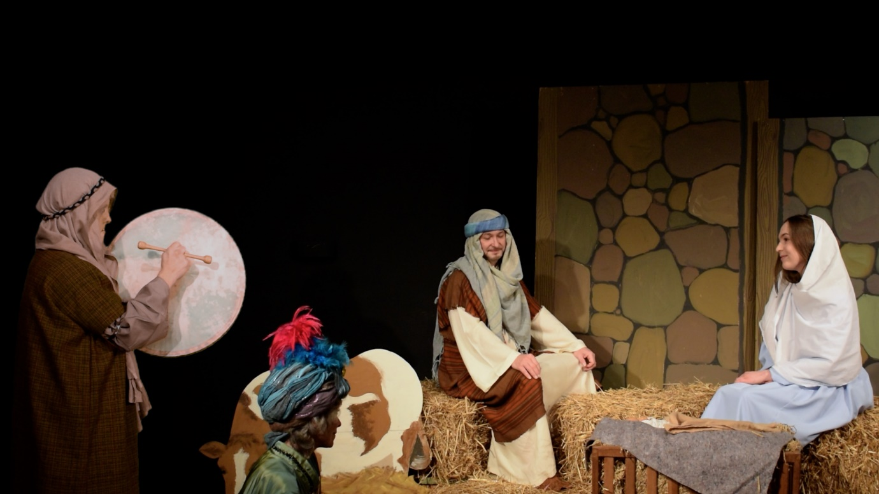

Allan Webster
Producer
The Dundee Nativity

